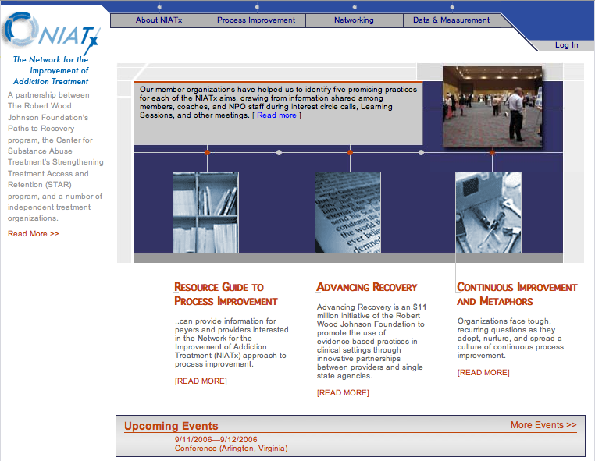
- The navigation bar at the top shows four key areas: About NIATx, Process Improvement, Networking, and Data & Measurement.
- The NIATx homepage has highlighted stories, resources, and case studies that feature the work of member agencies.
- At the bottom of the homepage is a calendar of upcoming events.

A QUICK TOUR of the NIATx WEB SITE
(www.niatx.net)
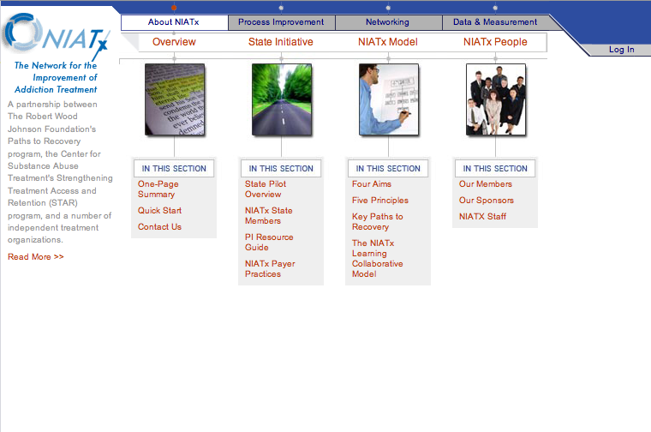
- The OVERVIEW section is the starting point for those who want to get a quick tour of NIATx.
- The ABOUT NIATx section provides background information on NIATx, process improvement, and our most important resource: people.
- The NIATx MODEL section expounds on the four aims, the five principles, the key paths to recovery, and the learning collaborative model that serves as the foundation of NIATx.
- The PEOPLE section provides profiles of NIATx member agencies, our sponsors, and the staff who get things done.

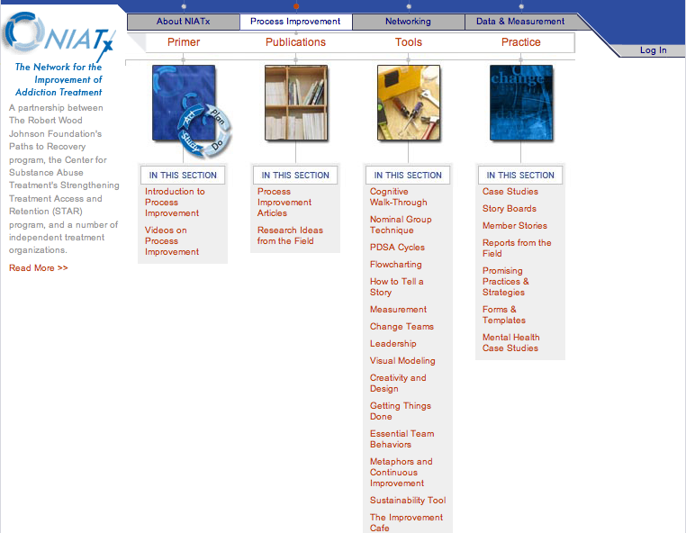
- The PRIMER is where people unfamiliar with process improvement learn the basic principles and methods.
- The PROCESS IMPROVEMENT section provides a good mix of theory and practise in the field of process improvement.
- The PUBLICATIONS section provides good references and articles on process improvement.
- The TOOLS section provides useful tools for carrying out improvement activities, such as brainstorming, problem-solving, and good execution.
- One of the most valuable sections on the Web site, the PRACTICE section is where case studies and other material showcase and detail how NIATx member agencies practise process improvement, and their subsequent impact on outcomes.

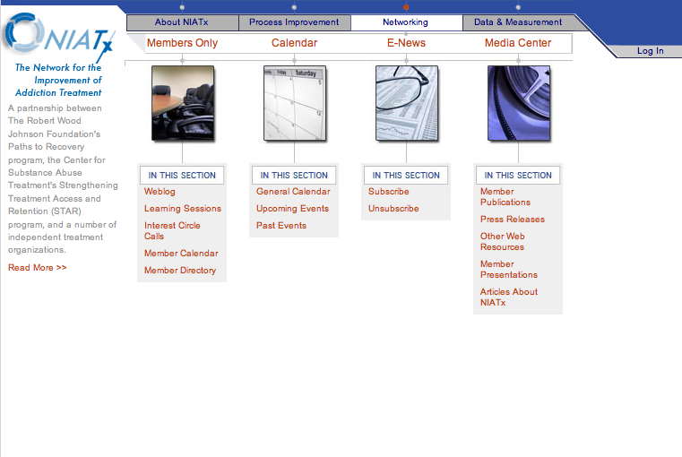
- The NETWORKING section contains resources that facilitate the exchange of ideas and information between members.
- The CALENDAR section provides a useful bird’s eye view of past and upcoming NIATx-related events.
- The E-NEWS section allows visitors to subscribe (or unsubscribe) from the monthly NIATx E-News service.

